1. *Log Aggregation - Logging is an essential part of effective troubleshooting. It’s an ongoing record of all the events in an application. When a service encounters an issue, a log message can help you find out the specific event that caused the disruption by describing what happened in the system and when. So, with the help of logging, IT teams can quickly identify the event that may have disrupted the production environment.* 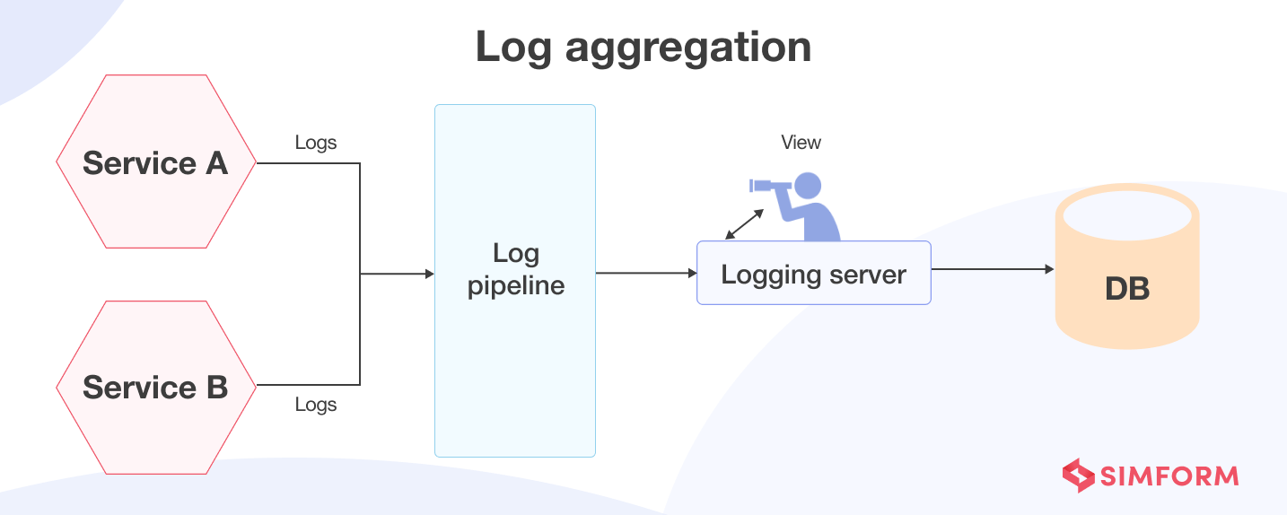

*However, retrieving information about service instances isn’t easy in the case of microservices architecture with thousands of distributed components. The log entries get spread across multiple services, each with its own log files. Also, a service instance only lasts for a short time. To overcome these challenges, development teams have adopted log aggregation as a microservices design pattern. Log aggregation uses a centralized log service that accumulates log files from every service instance. IT teams can retrieve, visualize, and analyze logs through the centralized log service.*

*Maintaining a central log repository also helps investigate specific problems and correlate them with individual services. Thus, accurate logging and aggregating log files provide full-stack visibility into the production environment.*